MongoDB Commands:

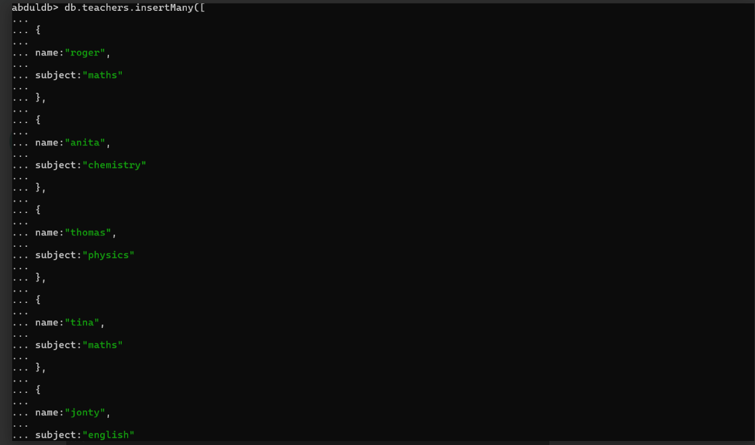

1. db.articles.find()

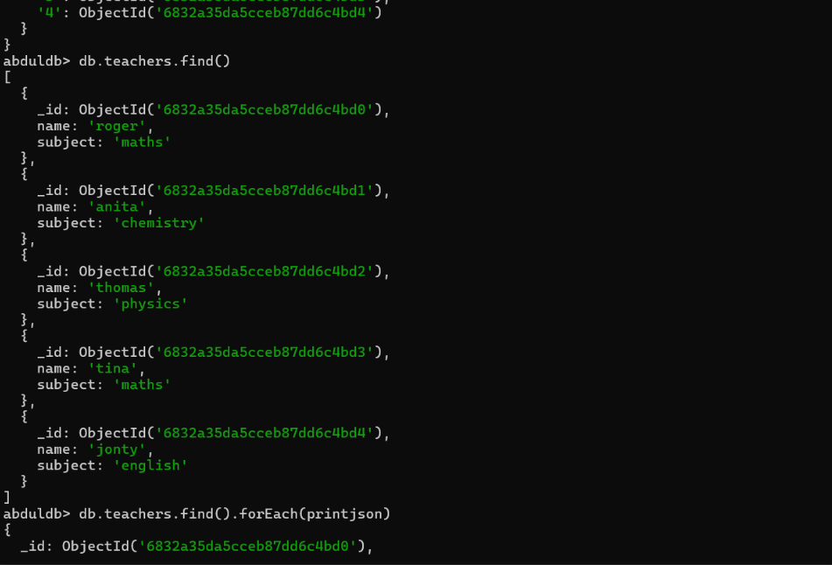

1. db.createCollection('atlas')

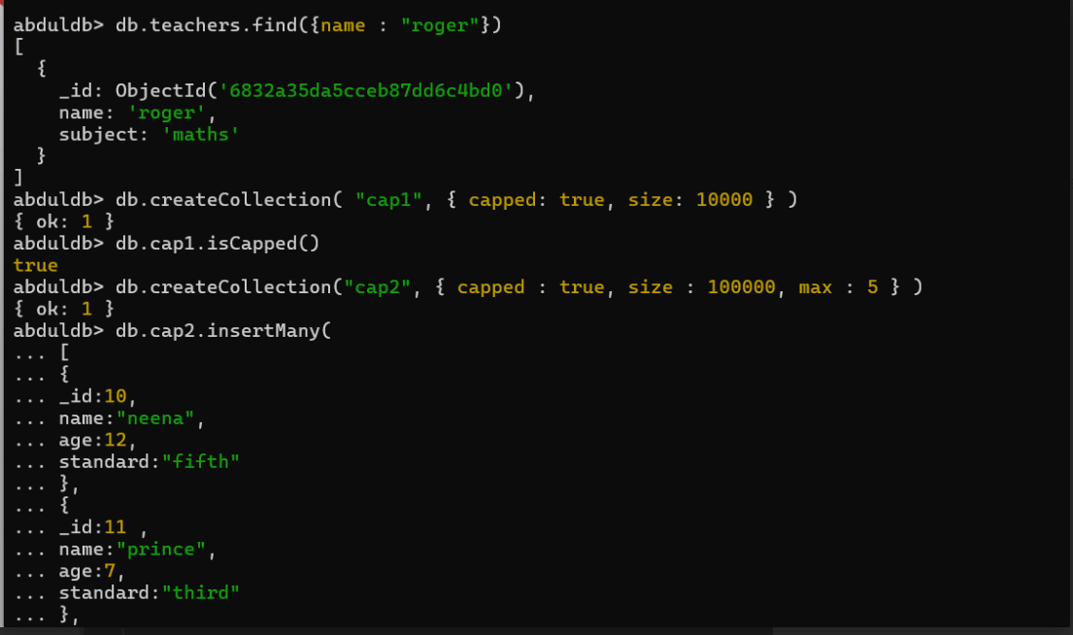

1. db.atlas.inserOne({name:"Samad", age:26, skills:["java", "linux", "git", "mongoDB","HTML", "JavaScript"]})
2. db.store.deleteOne({code:"def"})

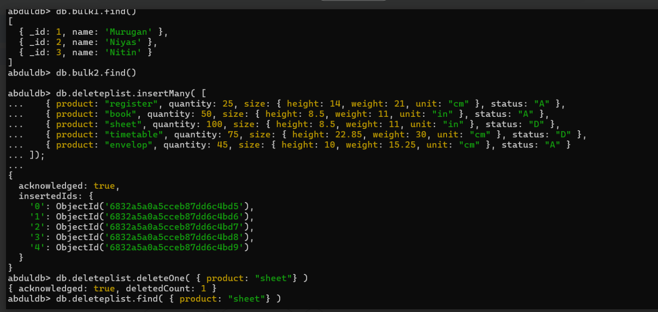

1. db.serverCmdLineOpts()
2. db.aggregateproduct.aggregate([ { $match: { status:"A" } }, { $group:{ _id:"$product",total:{ $sum:"$quantity"}}},{ $sort: { total: 1 }}])

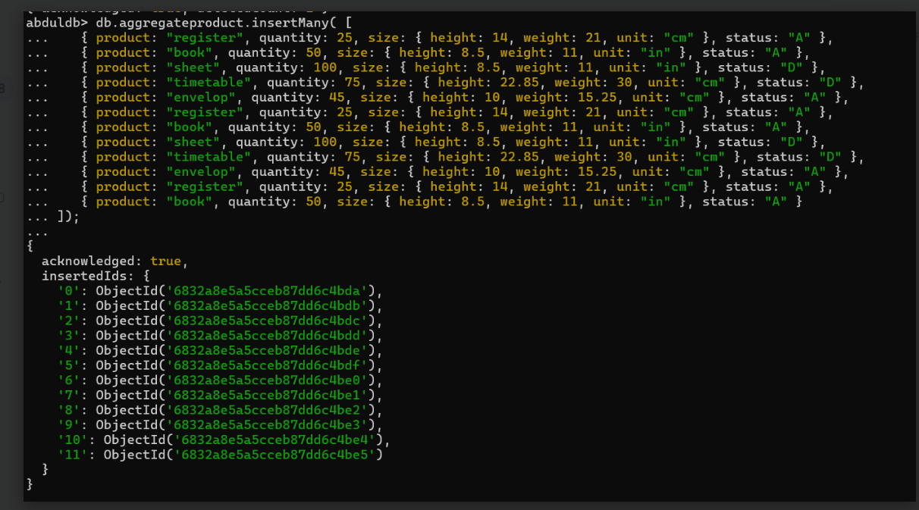

1. db.aggregateproduct.updateOne({_id:452},{$set:{name:"Samad", _id:"register"}},{upsert:true})

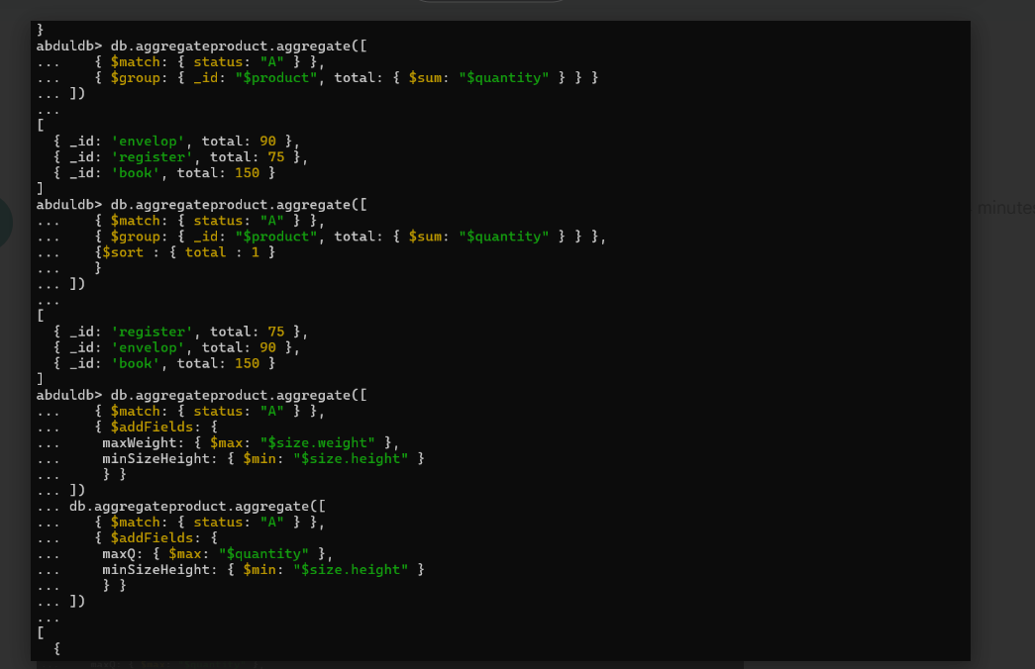

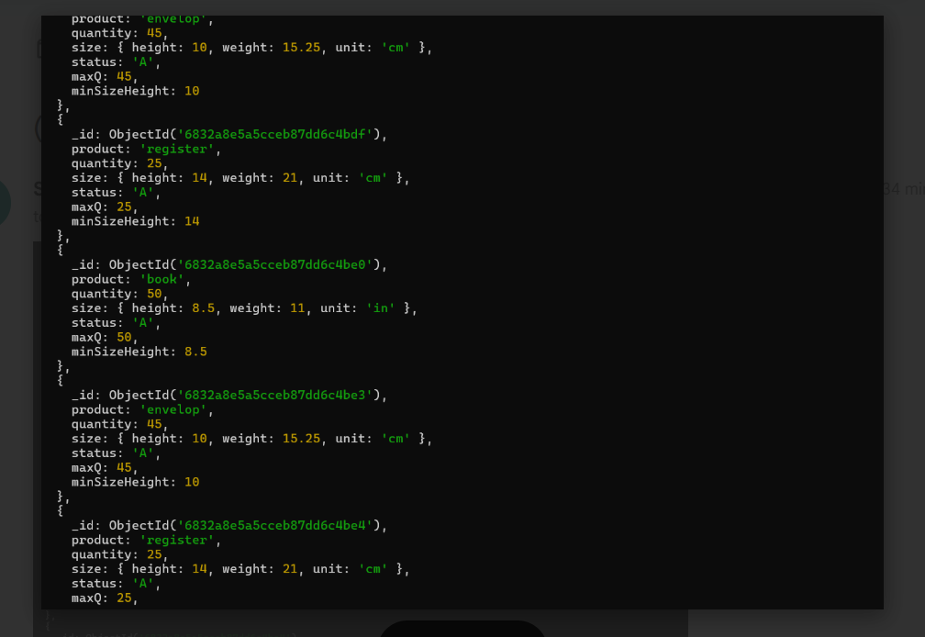

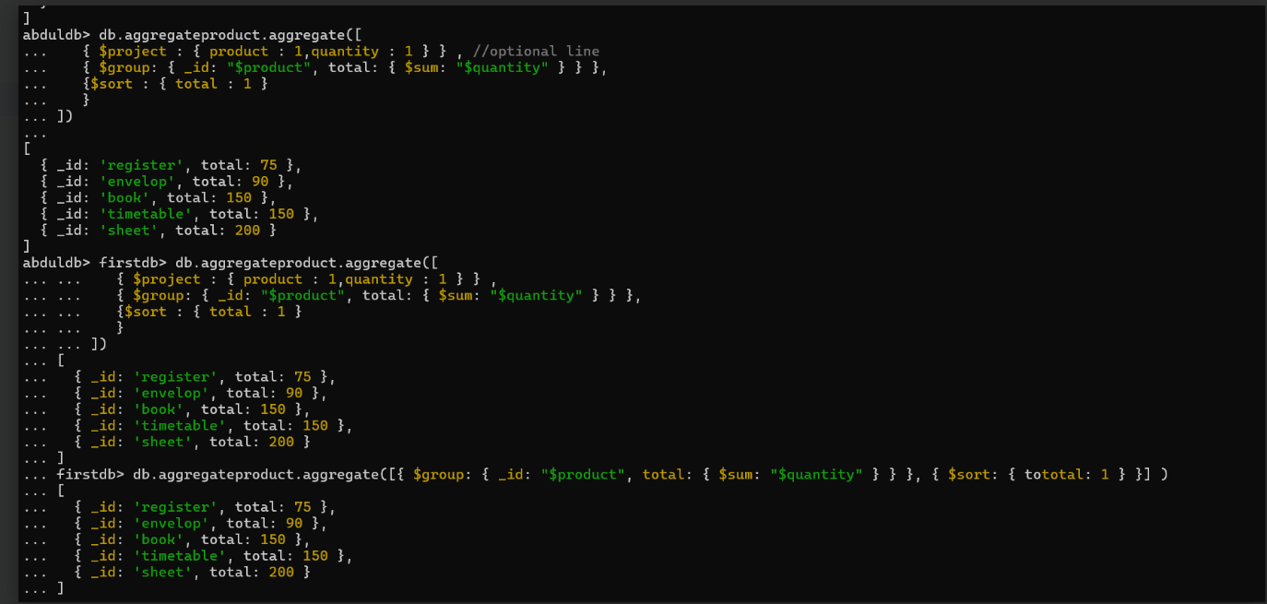

8. Pipeline:

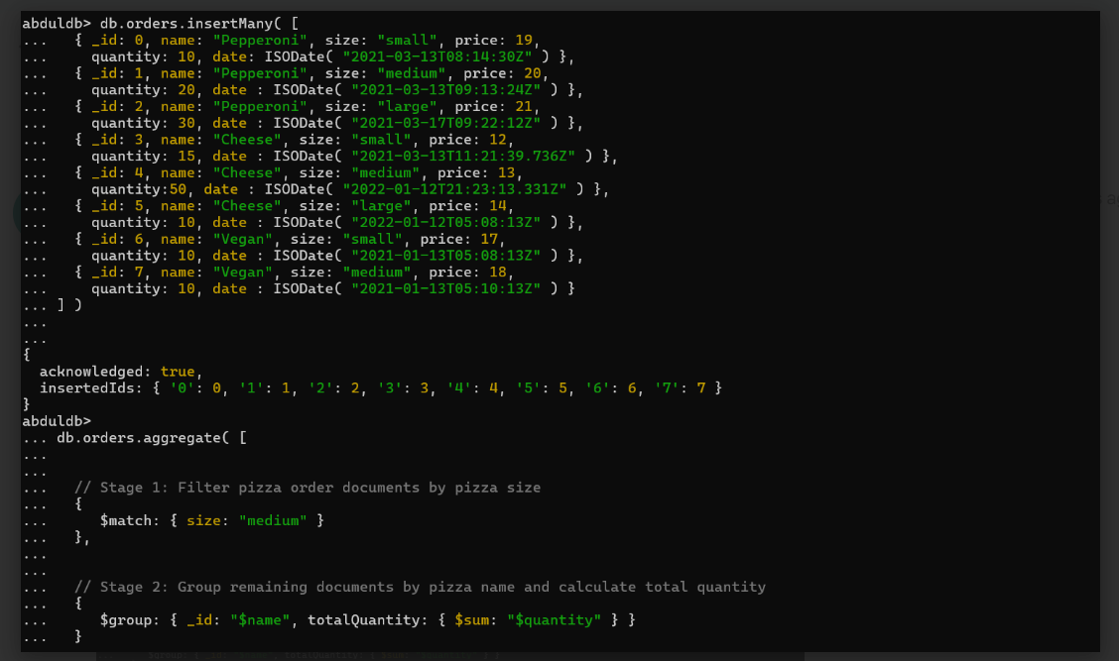

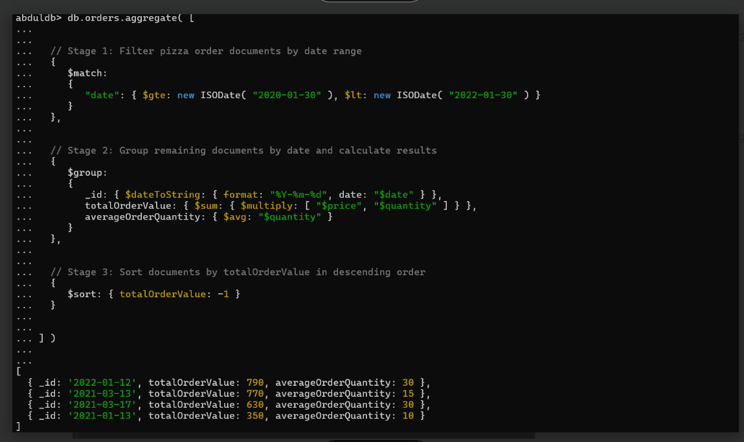

9. Indexing:

9. db.aggregateproduct.createIndex({product:"text"})

